PROJECT REPORT
URL PHISHING DETECTION
Dissertation submitted in partial fulfillment of the requirement
for the award of the Degree of
BACHELOR OF COMPUTER APPLICATION
Submitted by
BALAGANESH.K
2322J0100
Under the Guidance of
Dr.L.RAMESH, MSC(CS),.M.Phil(CS).,M.Lib.Isc.,NET-JRF.,SET.,Ph.D.,NET(LIS).,
Assistant Professor and Head, Department of Computational Sciences
RATHINAM COLLEGE OF LIBERAL ARTS AND SCIENCE AT TIPS GLOBAL

DEPARTMENT OF COMPUTATIONAL SCIENCES
RATHINAM COLLEGE OF LIBERAL ARTS AND SCIENCE AT TIPS GLOBAL
COIMBATORE- 641 107
MARCH 2026

CERTIFICATES

CERTIFICATE

This is to certify that the thesis, entitled “FAKE NEWS DETECTION” submitted in partial fulfillment of the requirements for the award of the Degree of BACHELO OF COMPUTER APPLICATION, is a record of original research work done by BALAGANESH.K 2323J0100 during the period 2025-2026 of her research in the Department of Computer Science, RATHINAM COLLEGE OF LIBERAL ARTS AND SCIENCE AT TIPS GLOBAL. COIMBATORE, under my supervision and guidance and the thesis has not formed the basis for the award of any Degree / Diploma / Associateship / Fellowship or other similar title of any candidate of any university.

Signature of the Guide

Countersigned

Head of the Department Principal

Date:

DECLARATION

DECLARATION

I,BALAGANESH.K hereby declare that the thesis, entitled “FAKE NEWS DETECTION” submitted in partial fulfillment of the requirements for the award of the Degree of BACHELOR OF COMPUTER APPLICATION, is a record of original and independent research work done by me during the year 2025-2026 under the Supervision and Guidance of
Dr.L.RAMESH,MSC(CS),.M.Phil(CS).,M.Lib.Isc.,NETJRF.,SET.,Ph.D.,NET(LIS)., Assistant Professor and Head of Computational Sciences , RATHINAM COLLEGE OF LIBERAL ARTS AND SCIENCE AT TIPS GLOBAL, COIMBATORE, and it has not formed the basis for the award of any Degree / Diploma / Associateship / Fellowship or other similar title to any candidate of any University.

Date: Signature of the Candidate

ACKNOWLEDGEMENT

ACKNOWLEDGEMENT

First and foremost, I express my sincere gratitude to my Research Guide and Supervisor, Dr. L. Ramesh, M.Sc. (CS), M.Phil. (CS), M.Lib.I.Sc., NET-JRF, SET, Ph.D., NET (LIS), Assistant Professor and Head of Computational Sciences at Rathinam College of Liberal Arts and Science at TIPS Global, Coimbatore, for his invaluable guidance, unwavering support, and constant motivation throughout the course of my research work. His profound knowledge, insightful suggestions, and scholarly contributions have been instrumental in shaping this dissertation. I am deeply indebted to him for his mentorship, which has not only enriched my academic journey but also helped this research report achieve its present form.

I extend my heartfelt thanks to Dr. K.P. Balakrishnan, M.Com., M.Phil., Ph.D., the Principal of Rathinam College of Liberal Arts and Science at TIPS Global, and Dr. Gunasekaran C, Campus Head, for providing me with the necessary resources and a conducive environment to carry out my research.
I would also like to acknowledge the faculty members of the Department of Computational Sciences for their encouragement, constructive feedback, and support during my academic tenure. Their expertise and guidance have been pivotal in my growth as a student and researcher.

My sincere gratitude goes to my family and friends for their unwavering belief in me, constant encouragement, and emotional support throughout this journey. Their love and motivation have been my driving force during challenging times.
Lastly, I thank everyone who has directly or indirectly contributed to the completion of this dissertation. This accomplishment would not have been possible without the collective support and guidance of all those mentioned above.

TABLE OF CONTENTS

Table of Contents
Chapter | Title | Page No.
Chapter 1 | Introduction
1.1 | Introduction
1.2 | Motivation
1.3 | Objectives
1.4 | Overview of the Project
Chapter 2 | Literature Review
2.1 | Media Rich Fake News Detection: A Survey
2.2 | Weakly Supervised Learning For Fake News Detection Twitter
2.3 | Fake News Detection Media
2.4 | Automatic Online Fake News Detection Combining Content And Social Signals
2.5 | The Spread Of Fake News By Social Bots
2.6 | Misleading Online Content
Chapter 3 | System Analysis
3.1 | Existing System
3.2 | Proposed System
3.3 | System Architectue
3.4 | System Requirements
3.5 | Software
3.6 | History of python
3.7 | Python Features
3.8 | Interactive Mode programming
3.9 | Script Mode Programming
3.10 | Flask Framework
3.11 | Modules
3.12 | Modules Desciption
3.13 | Word Embedding
Chapter 4 | Result And Discussion
4.1 | Requirement Analysis
4.2 | Functional Requirements
4.3 | Non -Functional Requirements
4.4 | System Design And Testing Plan
4.5 | Output Design
4.6 | Social Feasibility
4.7 | Data Flow Diagram
4.8 | Test Procedure
4.9 | Unit Testing
4.10 | Integration Testing
4.11 | Functional Testing
4.12 | White Box Testing
4.13 | Acceptance Testng
Chapter 5 | Advantages Of The Proposed Deep Learning Based LSTM System
5.1 | Disadvantage Of The Existing System
5.2 | Conclusion
5.3 | Future Enhancements
5.4 | References
5.5 | Bibliography
5.6 | Prediction Table
5.7 | Dfd
5.8 | Er Diagram
Chapter 6 | Conclusion And Future Wprk
6.1 | Conclusion
6.2 | References
6.3 | Appendix
6.4 | Output

CHAPTER 1

CHAPTER 2

CHAPTER 3

CHAPTER 4

CHAPTER 5

CHAPTER 6

aaaaa

ABSTRACT
In recent years, due to the booming development of online social networks, fake news for various commercial and political purposes has been appearing in large numbers and widespread in the online world. With deceptive words, online social network users can get infected by these online fake news easily, which has brought about tremendous effects on the offline society already. An important goal in improving the trustworthiness of information in online social networks is to identify the fake news timely. This paper aims at investigating the principles, methodologies and algorithms for detecting fake news articles, creators and subjects from online social networks and evaluating the corresponding performance. Information preciseness on Internet, especially on social media, is an increasingly important concern, but web-scale data hampers, ability to identify, evaluate and correct such data, or so called "fake news," present in these platforms. In this paper, we propose a method for "fake news" detection and ways to apply it on Facebook, one of the most popular online social media platforms. This method uses Naive Bayes classification model to predict whether a post on Facebook will be labeled as real or fake. The results may be improved by applying several techniques that are discussed in the paper. Received results suggest, that fake news detection problem can be addressed with machine learning methods.

CHAPTER 1

INTRODUCTION

1.1 Introduction
These days‟ fake news is creating different issues from sarcastic articles to a fabricated news and plan government propaganda in some outlets. Fake news and lack of trust in the media are growing problems with huge ramifications in our society. Obviously, a purposely misleading story is “fake news “ but lately blathering social media‟s discourse is changing its definition. Some of them now use the term to dismiss the facts counter to their preferred viewpoints.
The importance of disinformation within American political discourse was the subject of weighty attention , particularly following the American president election . The term 'fake news' became common parlance for the issue, particularly to describe factually incorrect and misleading articles published mostly for the purpose of making money through page views. In this paper,it is seeked to produce a model that can accurately predict the likelihood that a given article is fake news.Facebook has been at the epicenter of much critique following media attention. They have already implemented a feature to flag fake news on the site when a user sees‟s it ; they have also said publicly they are working on to to distinguish these articles in an automated way. Certainly, it is not an easy task. A given algorithm must be politically unbiased – since fake news exists on both ends of the spectrum – and also give equal balance to legitimate news sources on either end of the spectrum. In addition, the question of legitimacy is a difficult one.However, in order to solve this problem, it is necessary to have an understanding on what Fake News.

1.2 Motivation
We will be training and testing the data, when we use supervised learning it means we are labeling the data. By getting the testing and training data and labels we can perform different machine learning algorithms but before performing the predictions and accuracies, the data is need to be preprocessing i.e. the null values which are not readable are required to be removed from the data set and the data is required to be converted into vectors by normalizing and tokening the data so that it could be understood by the machine. Next step is by using this data, getting the visual reports, which we will get by using the Mat Plot Library of Python and Sickit Learn. This library helps us in getting the results in the form of histograms, pie charts or bar charts.

1.3 Objectives
The objective of this project is to examine the problems and possible significances related with the spread of fake news. We will be working on different fake news data set in which we will apply different machine learning algorithms to train the data and test it to find which news is the real news or which one is the fake news. As the fake news is a problem that is heavily affecting society and our perception of not only the media but also facts and opinions themselves. By using the artificial intelligence and the machine learning, the problem can be solved as we will be able to mine the patterns from the data to maximize well defined objectives. So, our focus is to find which machine learning algorithm is best suitable for what kind of text dataset. Also, which dataset is better for finding the accuracies as the accuracies directly depends on the type of data and the amount of data. The more the data, more are your chances of getting correct accuracy as you can test and train more data to find out your results.

1.4 Overview of the Project
With the advancement of technology, digital news is more widely exposed to users globally and contributes to the increment of spreading and disinformation online. Fake news can be found through popular platforms such as social media and the Internet. There have been multiple solutions and efforts in the detection of fake news where it even works with tools. However, fake news intends to convince the reader to believe false information which deems these articles difficult to perceive. The rate of producing digital news is large and quick, running daily at every second, thus it is challenging for machine learning to effectively detect fake news

CHAPTER 2

LITERATURE REVIEW

The available literature has described many automatic detection techniques of fake news and deception posts. Since there are multidimensional aspects of fake news detection ranging from using chatbots for spread of misinformation to use of clickbaits for the rumor spreading . There are many clickbaits available in social media networks including facebook which enhance sharing and liking Proceedings of posts which in turn spreads falsified information. Lot of work has been done to detect falsified information.

2.1 MEDIA RICH FAKE NEWS DETECTION: A SURVEY

Ingeneral, the goal is profiting through clickbaits. Clickbaits lure users and entice curiosity with flashy headlines or designs to click links to increase advertisements revenues. This exposition analyzes the prevalence of fake news in light of the advances in communication made possible by the emergence of social networking sites. The purpose of the work is to come up with a solution that can be utilized by users to detect and filter out sites containing false and misleading information. We use simple and carefully selected features of the title and post to accurately identify fake posts. The experimental results show a 99.4% accuracy using logistic classifier.

2.2 WEAKLY SUPERVISED LEARNING FOR FAKE NEWS DETECTION TWITTER

The problem of automatic detection of fake news in social media, e.g., on Twitter, has recently drawn some attention. Although, from a technical perspective, it can be regarded as a straight-forward, binary classification problem, the major challenge is the collection of large enough training corpora, since manual annotation of tweets as fake or non-fake news is an expensive and tedious endeavor. In this paper, we discuss a weakly supervised approach, which automatically collects a large-scale, but very noisy training dataset comprising hundreds of thousands of tweets. During collection, we automatically label tweets by their source, i.e., trustworthy or untrustworthy source, and train a classifier on this dataset. We then use that classifier for a different classification target, i.e., the classification of fake and non- fake tweets. Although the labels are not accurate according to the new classification target (not all tweets by an untrustworthy source need to be fake news, and vice versa), we show that despite this unclean inaccurate dataset, it is possible to detect fake news with an F1 score of up to 0.9.

2.3 FAKE NEWS DETECTION IN SOCIAL MEDIA

Fake news and hoaxes have been there since before the advent of the Internet. The widely accepted definition of Internet fake news is: fictitious articles deliberately fabricated to deceive readers”. Social media and news outlets publish fake news to increase readership or as part of psychological warfare. Ingeneral, the goal is profiting through clickbaits. Clickbaits lure users and entice curiosity with flashy headlines or designs to click links to increase advertisements revenues. This exposition analyzes the prevalence of fake news in light of the advances in communication made possible by the emergence of social networking sites. The purpose of the work is to come up with a solution that can be utilized by users to detect and filter out sites containing false and misleading information. We use simple and carefully selected features of the title and post to accurately identify fake posts. The experimental results show a 99.4% accuracy using logistic classifier.

2.4 AUTOMATIC ONLINE FAKE NEWS DETECTION COMBINING CONTENT AND SOCIAL SIGNALS

The proliferation and rapid diffusion of fake news on the Internet highlight the need of automatic hoax detection systems. In the context of social networks, machine learning (ML) methods can be used for this purpose. Fake news detection strategies are traditionally either based on content analysis (i.e. analyzing the content of the news) or - more recently - on social context models, such as mapping the news‟ diffusion pattern. In this paper, we first propose a novel ML fake news detection method which, by combining news content and social context features, outperforms existing methods in the literature, increasing their already high accuracy by up to 4.8%. Second, we implement our method within a Facebook Messenger chatbot and validate it with a real-world application, obtaining a fake news detection accuracy of 81.7%.
In recent years, the reliability of information on the Internet has emerged as a crucial issue of modern society. Social network sites (SNSs) have revolutionized the way in which information is spread by allowing users to freely share content. As a consequence, SNSs are also increasingly used as vectors for the diffusion of misinformation and hoaxes. The amount of disseminated information and the rapidity of its diffusion make it practically impossible to assess reliability in a timely manner, highlighting the need for automatic hoax detection systems.As a contribution towards this objective, we show that Facebook posts can be classified with high accuracy as hoaxes or non-hoaxes on the basis of the users who "liked" them. We present two classification techniques, one based on logistic regression, the other on a novel adaptation of boolean crowdsourcing algorithms. On a dataset consisting of 15,500 Facebook posts and 909,236 users, we obtain classification accuracies exceeding 99% even when the training set contains less than 1% of the posts. We further show that our techniques are robust: they work even when we restrict our attention to the users who like both hoax and non-hoax posts. These results suggest that mapping the diffusion pattern of information can be a useful component of automatic hoax detection systems.

2.5 THE SPREAD OF FAKE NEWS BY SOCIAL BOTS

The massive spread of fake news has been identified as a major global risk and has been alleged to influence elections and threaten democracies. Communication, cognitive, social, and computer scientists are engaged in efforts to study the complex causes for the viral diffusion of digital misinformation and to develop solutions, while search and social media platforms are beginning to deploy countermeasures. However, to date, these efforts have been mainly informed by anecdotal evidence rather than systematic data. Here we analyze 14 million messages spreading 400 thousand claims on Twitter during and following the 2016 U.S. presidential campaign and election. We find evidence that social bots play a key role in the spread of fake news. Accounts that actively spread misinformation are significantly more likely to be bots. Automated accounts are particularly active in the early spreading phases of viral claims, and tend to target influential users. Humans are vulnerable to this manipulation, retweeting bots who post false news. Successful sources of false and biased claims are heavily supported by social bots. These results suggests that curbing social bots may be an effective strategy for mitigating the spread of online misinformation.

2.6 MISLEADING ONLINE CONTENT

Tabloid journalism is often criticized for its propensity for exaggeration, sensationalization, scare-mongering, and otherwise producing misleading and low quality news. As the news has moved online, a new form of tabloidization has emerged: „clickbaiting.‟ „Clickbait‟ refers to “content whose main purpose is to attract attention and encourage visitors to click on a link to a particular web page” [„clickbait,‟ n.d.] and has been implicated in the rapid spread of rumor and misinformation online. This paper examines potential methods for the automatic detection of clickbait as a form of deception. Methods for recognizing both textual and non-textual clickbaiting cues are surveyed, leading to the suggestion that a hybrid approach may yield best results.
Big Data Analytics and Deep Learning are two high-focus of data science. Big Data has become important as many organizations both public and private have been collecting massive amounts of domain-specific information, which can contain useful information about problems such as national intelligence, cyber security, fraud detection, marketing, and medical informatics. Companies such as Google and Microsoft are analyzing large volumes of data for business analysis and decisions, impacting existing and future technology. Deep Learning algorithms extract high- level, complex abstractions as data representations through a hierarchical learning process. Complex abstractions are learnt at a given level based on relatively simpler abstractions formulated in the preceding level in the hierarchy. A key benefit of Deep Learning is the analysis and learning of massive amounts of unsupervised data, making it a valuable tool for Big Data Analytics where raw data is largely unlabeled and un-categorized. In the present study, we explore how Deep Learning can be utilized for addressing some important problems in Big Data Analytics, including extracting complex patterns from massive volumes of data, semantic indexing, data tagging, fast information retrieval, and simplifying discriminative tasks. We also investigate some aspects of Deep Learning research that need further exploration to incorporate specific challenges introduced by Big Data Analytics, including streaming data, high-dimensional data, scalability of models, and distributed computing. We conclude by presenting insights into relevant future works by posing some questions, including defining data sampling criteria, domain adaptation modeling, defining criteria for obtaining useful data abstractions, improving semantic indexing, semi - supervised learning, and active learning.
CHAPTER 3
SYSTEM ANALYSIS

3.1 EXISTING SYSTEM

There exists a large body of research on the topic of machine learning methods for deception detection, most of it has been focusing on classifying online reviews and publicly available social media posts. Particularly since late 2016 during the American Presidential election, the question of determining 'fake news' has also been the subject of particular attention within the literature. Conroy, Rubin, and Chen outlines several approaches that seem promising towards the aim of perfectly classify the misleading articles. They note that simple content-related n-grams and shallow parts-of-speech tagging have proven insufficient for the classification task, often failing to account for important context information. Rather, these methods have been shown useful only in tandem with more complex methods of analysis. Deep Syntax analysis using Probabilistic Context Free Grammars have been shown to be particularly valuable in combination with n-gram methods. Feng, Banerjee, and Choi are able to achieve 85%-91% accuracy in deception related classification tasks using online review corpora.

3.2 PROPOSED SYSTEM

The proposed system is based on a Deep Learning approach using a Long Short-Term Memory (LSTM) network, which is a type of recurrent neural network designed to learn patterns from sequential or time-dependent data. In this system, the collected dataset is first preprocessed to remove noise, handle missing values, and convert the raw data into a structured numerical format suitable for model training. Relevant features are then extracted from the processed data to represent meaningful patterns. These features are provided as input to the LSTM model, which is capable of capturing long-term dependencies and temporal relationships within the data. The model consists of an input layer, one or more LSTM layers to learn sequential patterns, dropout layers to reduce overfitting, and dense layers to perform the final classification or prediction. The dataset is divided into training and testing sets to evaluate the performance of the model. During the training phase, the LSTM network learns important patterns and relationships in the dataset, allowing it to make accurate predictions. Once trained, the model can analyze new input data and generate prediction results effectively. The proposed deep learning-based LSTM system improves accuracy and efficiency in detecting patterns compared to traditional machine learning techniques, making it suitable for applications such as audio signal analysis, behavioral monitoring, and time-series prediction

3.3SYSTEM ARCHITECTURE

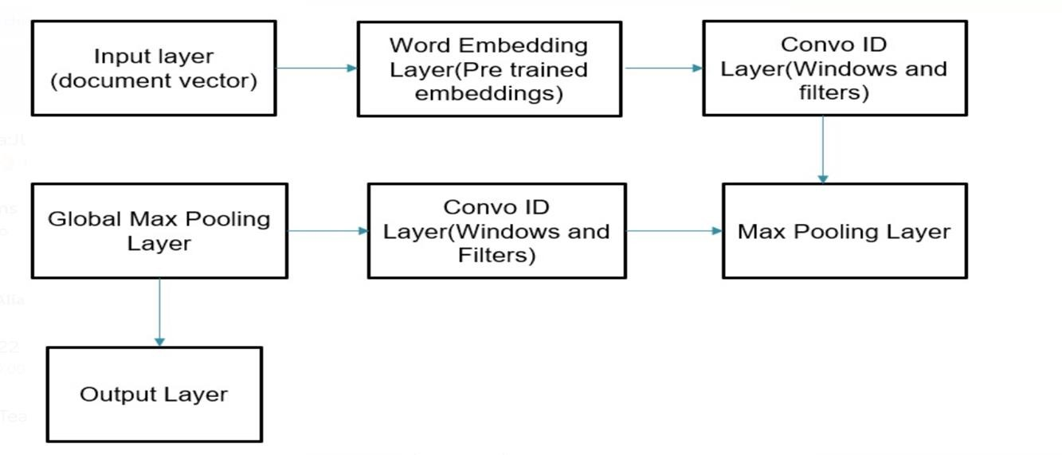

Fig:3.1 Architecture diagram

3.4 SYSTEM REQUIREMENTS
HARDWARE REQUIREMENTS:

- System - Pentium-IV
- Speed - 2.4GHZ
- Hard disk - 40GB
- Monitor - 15VGA color
- RAM - 512MB

SOFTWARE REQUIREMENTS:
  - Operating System - Windows XP
  - Coding language - PYTHON with Flask
  - Front End - HTML, CSS, Bootstrap, JavaScript

3.5 SOFTWARE

ENVIRONMENT PYTHON
Python is a high-level, interpreted, interactive and object-oriented scripting language. Python is designed to be highly readable. It uses English keywords frequently where as other languages use punctuation, and it has fewer syntactical constructions than other languages.

- Python is Interpreted − Python is processed at runtime by the interpreter. You do not need to compile your program before executing it. This is similar to PERL and PHP.
- Python is Interactive − You can actually sit at a Python prompt and interact with the interpreter directly to write your programs.
- Python is Object-Oriented − Python supports Object-Oriented style or technique of programming that encapsulates code within objects.
- Python is a Beginner's Language − Python is a great language for the beginner-level programmers and supports the development of a wide range of applications from simple text processing to WWW browsers to games.

3.6 History of Python

Python was developed by Guido van Rossum in the late eighties and early nineties at the National Research Institute for Mathematics and Computer Science in the Netherlands.
Python is derived from many other languages, including ABC, Modula-3, C, C++, Algol-68, SmallTalk, and Unix shell and other scripting languages.
Python is copyrighted. Like Perl, Python source code is now available under the GNU General Public License (GPL).
Python is now maintained by a core development team at the institute, although Guido van Rossum still holds a vital role in directing its progress.

3.7 PYTHON FEATURES

Python's features include −

- Easy-to-learn − Python has few keywords, simple structure, and a clearly defined syntax. This allows the student to pick up the language quickly.
- Easy-to-read − Python code is more clearly defined and visible to the eyes. Easy-to-maintain − Python's source code is fairly easy-to-maintain.

- A broad standard library − Python's bulk of the library is very portable and cross-platform compatible on UNIX, Windows, and Macintosh.
- Interactive Mode − Python has support for an interactive mode which allows interactive testing and debugging of snippets of code.
- Portable − Python can run on a wide variety of hardware platforms and has the same interface on all platforms.
- Extendable − You can add low-level modules to the Python interpreter. These modules enable programmers to add to or customize their tools to be more efficient.
- Databases − Python provides interfaces to all major commercial databases.

- GUI Programming − Python supports GUI applications that can be created and ported to many system calls, libraries and windows systems, such as Windows MFC, Macintosh, and the X Window system of Unix.
- Scalable − Python provides a better structure and support for large programs than shell scripting.
Apart from the above-mentioned features, Python has a big list of good features, few are listed below −
- It supports functional and structured programming methods as well as OOP.

- It can be used as a scripting language or can be compiled to byte-code for building large applications.
- It provides very high-level dynamic data types and supports dynamic type checking.
- It supports automatic garbage collection.

- It can be easily integrated with C, C++, COM, ActiveX, CORBA, and Java.

Python is available on a wide variety of platforms including Linux and Mac OS X. Let's understand how to set up our Python environment.

Getting Python

The most up-to-date and current source code, binaries, documentation, news, etc., is available on the official website of Python https://www.python.org.
Windows Installation

Here are the steps to install Python on Windows machine.

- Open a Web browser and go to https://www.python.org/downloads/.

- Follow the link for the Windows installer python-XYZ.msifile where XYZ is the version you need to install.
- To use this installer python-XYZ.msi, the Windows system must support Microsoft Installer 2.0. Save the installer file to your local machine and then run it to find out if your machine supports MSI.
- Run the downloaded file. This brings up the Python install wizard, which is really easy to use. Just accept the default settings, wait until the install is finished, and you are done.
The Python language has many similarities to Perl, C, and Java. However, there are some definite differences between the languages.

3.8 INTERACTIVE MODE PROGRAMMING
Invoking the interpreter without passing a script file as a parameter brings up the following prompt –
$ python

Python2.4.3(#1,Nov112010,13:34:43)

[GCC 4.1.220080704(RedHat4.1.2-48)] on linux2

Type"help","copyright","credits"or"license"for more information.

>>>
Type the following text at the Python prompt and press the Enter −
>>>print"Hello, Python!"
If you are running new version of Python, then you would need to use print statement with parenthesis as in print ("Hello, Python!");. However in Python version 2.4.3, this produces the following result −
Hello, Python!

3.9 SCRIPT MODE PROGRAMMING

Invoking the interpreter with a script parameter begins execution of the script and continues until the script is finished. When the script is finished, the interpreter is no longer active.
Let us write a simple Python program in a script. Python files have extension .py. Type the following source code in a test.py file –
print"Hello, Python!"

We assume that you have Python interpreter set in PATH variable. Now, try to run this program as follows –
$ python test.py

This produces the following result −
Hello, Python!

3.10 FLASK FRAMEWORK
Flask is a web application framework written in Python. Armin Ronacher, who leads an international group of Python enthusiasts named Pocco, develops it. Flask is based on Werkzeug WSGI toolkit and Jinja2 template engine. Both are Pocco projects.
Http protocol is the foundation of data communication in world wide web. Different methods of data retrieval from specified URL are defined in this protocol.

The following table summarizes different http methods −

Sr.No | Methods & Description
1 | GET  Sends data in unencrypted form to the server. Most common method.
2 | HEAD  Same as GET, but without response body
3 | POST  Used to send HTML form data to server. Data received by POST method is not cached by server.
4 | PUT  Replaces all current representations of the target resource with the uploaded content.
5 | DELETE  Removes all current representations of the target resource given by a URL

By default, the Flask route responds to the GETrequests. However, this preference can be altered by providing methods argument to route() decorator.
In order to demonstrate the use of POST method in URL routing, first let us create an HTML form and use the POST method to send form data to a URL.
Save the following script as login.html

<html>

<body>

<formaction="http://localhost:5000/login"method="post">

<p>Enter Name:</p>

<p><inputtype="text"name="nm"/></p>

<p><inputtype="submit" value="submit"/></p>

</form>

</body>

</html>
Now enter the following script in Python shell.
from flask importFlask, redirect,url_for, request

app=Flask( name )

@app.route('/success/<name>') def success(name): return'welcome %s'% name
@app.route('/login',methods=['POST','GET']) def login():
ifrequest.method=='POST': user=request.form['nm']
return redirect(url_for('success',name= user)) else:
user=request.args.get('nm')

return redirect(url_for('success',name= user)) if name ==' main ':
app.run(debug =True)
After the development server starts running, open login.html in the browser, enter name in the text field and click Submit

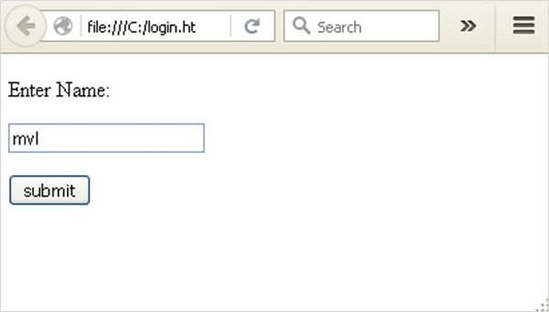

Fig:3.2 Login page
Form data is POSTed to the URL in action clause of form tag.
http://localhost/login is mapped to the login() function. Since the server has received data by POST method, value of „nm‟ parameter obtained from the form data is obtained by −
user = request.form['nm']

It is passed to „/success‟ URL as variable part. The browser displays a welcome
message in the window.

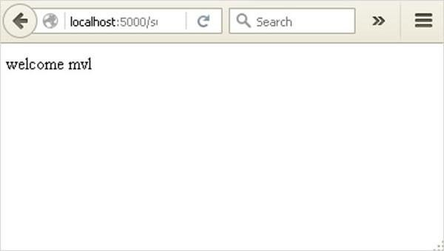
Fig:3.3 Dashboard

Change the method parameter to „GET‟ in login.html and open it again in the browser. The data received on server is by the GET method. The value of „nm‟ parameter is now obtained by –
User = request.args.get(„nm‟)

Here, args is dictionary object containing a list of pairs of form parameter and its corresponding value. The value corresponding to „nm‟ parameter is passed on to
„/success‟ URL as before.

3.11 MODULES

- Data Use
- Preprocessing
- Feature Extraction
- Training the Classifier

3.12 MODULES DESCRIPTION

Dataset Collection

Dataset is collected from Kaggle that is-Fake and real news dataset

Two files are used-:
Fake.csv-consist of 4 columns
    - Title-The title of the article
    - Text-The text of the article
    - Subject-The subject of the article
    - Date-The date at which the article was posted

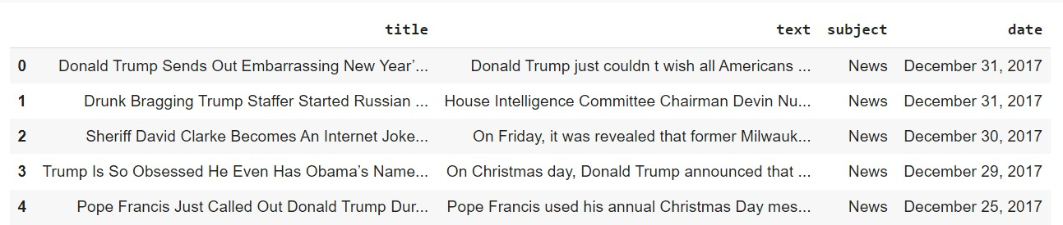

Figure 3.1: SCREENSHOT of Fake dataset
True.csv-consist of 4 columns
    - Title-The title of the article
    - Text-The text of the article
    - Subject-The subject of the article
    - Date-The date at which the article was posted

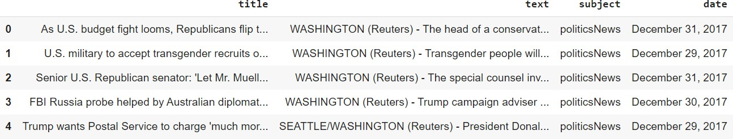

Figure 3.2: SCREENSHOT of True dataset
The number of fake news (0) are-23481 and number of True news (1) are-21417

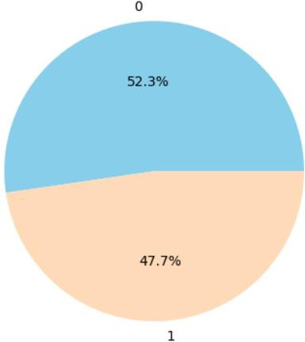

Graph 3.1: Pie Chart for Fake and True News

    - It consists of variety of news-

politics News | 11272
world news | 10145
News | 9050
politics | 6841
left-news | 4459
Government News | 1570
US_News | 783
Middle-east | 778
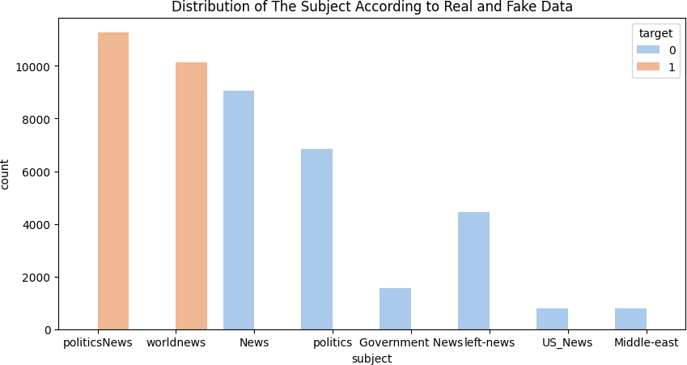

Graph 3.2: Bar Graph for distribution of the Subject According to Real and Fake data

Tokenization

Tokenization is the process of separating natural language text and unstructured data into units of data that may be viewed as discrete chunks. Token occurrences in a document can be used directly as a vector to express the text.

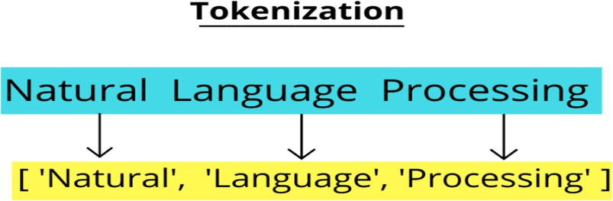

Figure 3.3: Tokenization

Why do we need Tokenization?

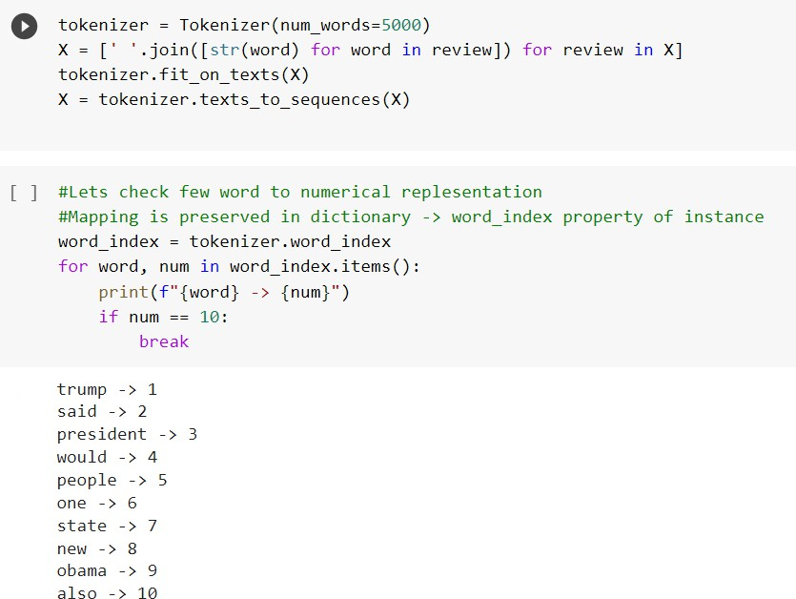
The initial stage in every NLP pipeline is tokenization. It significantly affects the remainder of your pipeline. We could wish to count the number of times each word appears in the provided text by dividing it up into tokens.

Figure 3.4: Tokenizing is done

Data Preprocessing

To apply machine learning or deep learning algorithms to text data, extra preprocessing is needed. Text data can be transformed using a number of methods that are frequently used to create models- ready formats. The headlines and news items are subjected to the data preparation methods that we describe below.
1.Stop Word Removal 2.Punctuation Removal
3.Lemmatization

Stop words are those that are usually overlooked while analyzing natural language. Even though these are some of the most widely used words in any language, the text does not gain much information from them. The words “a", ''the'', "is”, “very" and "so" are some examples of stop words in English.

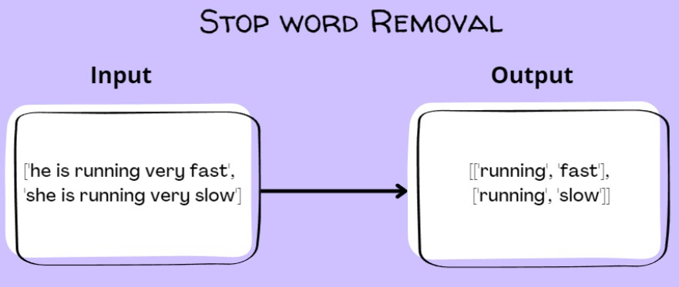

Figure 3.5: Stop word removal
Why do we remove stop words?

There are many stop words in every human language. We can make our text more centered on the valuable information by getting rid of these words and cutting out the low-level information. To put it another way, we claim that the model we create for our research does not demonstrate any negative effects as a result of the removal of such sentences.
The dataset's size and, subsequently, the training time are minimized by excluding stop words.

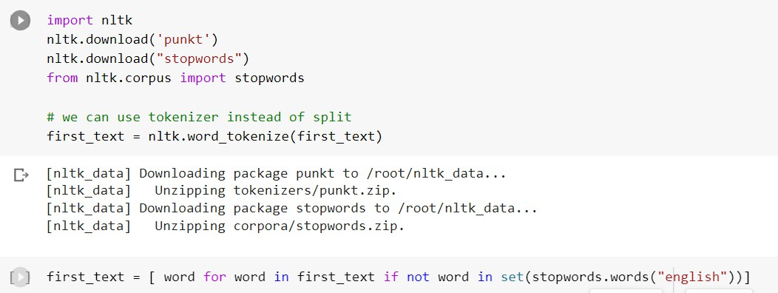
Figure 3.6: Stop word removal code

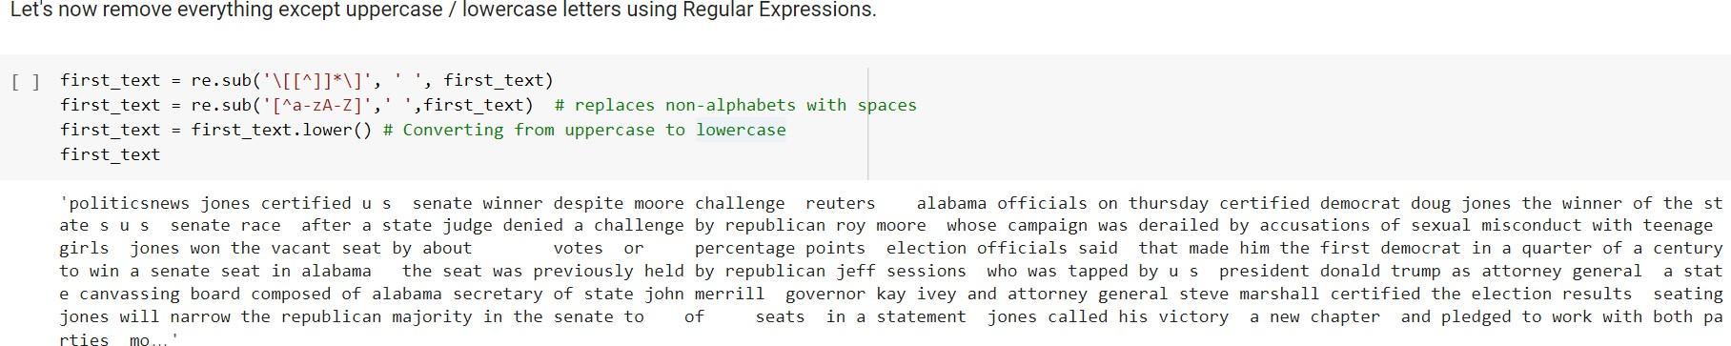

Figure 3.7: Removal of Punctuation Marks and Special Characters

Lemmatization
Lemmatization is a method of natural language processing that includes stripping a word down to its most basic or dictionary form, or lemma. It is a crucial component of text preprocessing and is frequently applied to tasks like text categorization, sentiment analysis, and information retrieval.

Depending on the tense, number, and context of a word, it can have various forms in English. For instance, the word "child" might be written as "children" or "child's", while the verb "run" can be written as "running", "ran", or "runs". All these distinct spellings of the same word can be reduced to their respective base forms—"run" and "child"—by using lemmatization.
Lemmatization is distinct from stemming, another text preparation method that entails stripping words of their suffixes to return them to their original form. Although stemming is quicker and easier than lemmatization, it may produce non-words or incorrectly spelt words, which may impair the accuracy of subsequent tasks.
A lemmatizer, a tool or library that maps words to their base form based on their part of speech, is used in lemmatization. The word "running," for instance, may be lemmatized to "run" if it is understood to be a verb, but it could also be lemmatized to "running" if it is understood to be a noun.

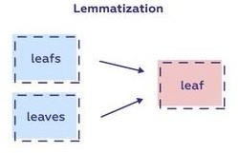
Figure 3.8: Lemmatization
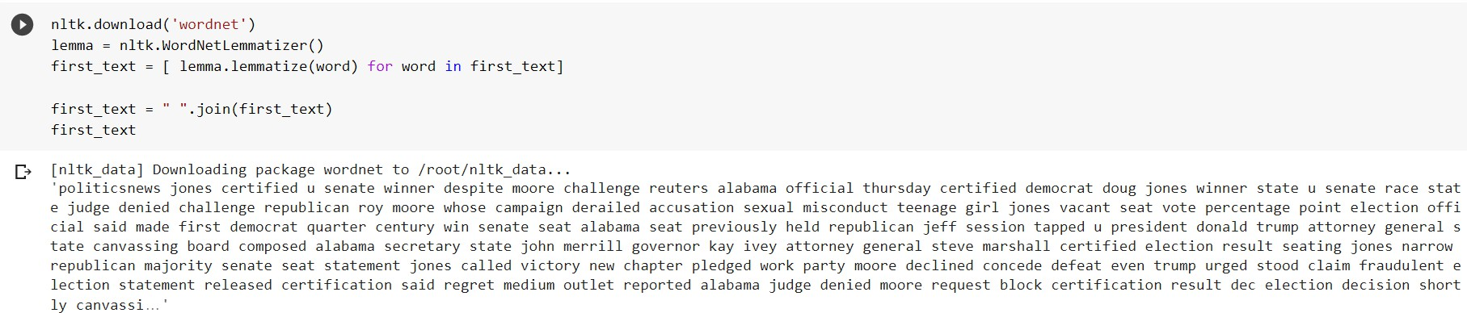

Figure 3.9: Lemmatization code

3.13 WORD EMBEDDING

It is a technique for presenting printed words and materials. A word is represented by a lower- dimensional numeric vector input called a word vector or word embedding. It allows for comparable representations of words with comparable meanings. Additionally, they can loosely convey meaning. A word vector can represent 100 different qualities with its 100 values.
Features: Any element that connects words to one another. For instance, age, occupation, fitness, and sports. Values for each word vector relate to these features.

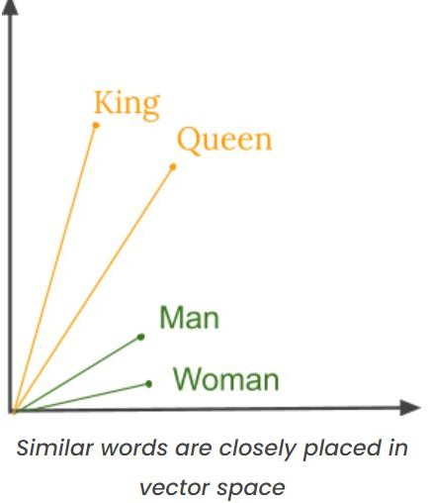

Figure 3.10: words in vector space
Goal of Word Embeddings

1. To significantly reduce the dimensionality.
2.Use a letter to foretell the words surrounding it.
3.The inter word relationship must be recorded.

How are Word Embeddings used?

They generate input for models of machine learning. words —->numeric representation —-> Used for training.
To represent or display any usage patterns that may have been in the corpus used to train them.

Implementations of Word Embeddings:

Word embeddings are a technique for taking the features from text and putting them into a machine learning model that can work with text data. They make an effort to maintain semantic and syntactic information. The word count in a sentence is used by techniques like Bag of Words (BOW), Count Vectorizer, and TFIDF, although no syntactic or semantic data is saved. The amount of vocabulary elements in these methods determines the size of the vector. If the majority of the elements are 0, we can have a sparse matrix. Large input vectors will result in a great deal of weights, which will increase the amount of training computation needed. Word embeddings offer an answer to these issues.

GloVe

Researchers Jeffrey Pennington, Richard Socher, and Chris Manning from the Stanford NLP Group have released a programme called GloVe (Global Vectors for Word Representation) for learning continuous-space vector representations of words.
These word vectors have been demonstrated to have intriguing semantic and syntactic regularities. For instance, we discover that the following statements are true for the related word.

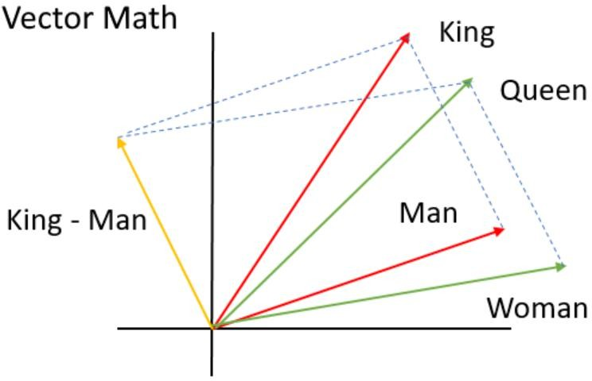
King - man + woman=queen Brought - bring +seek=sought

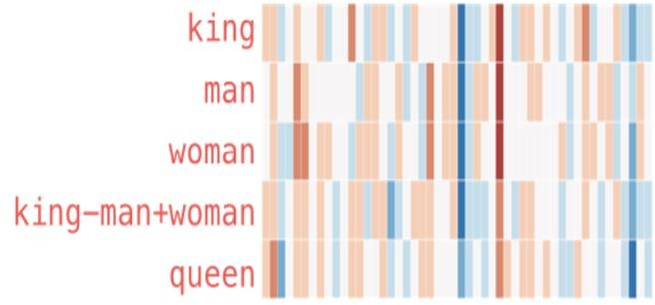

Figure 3.11: GloVe preserving semantic and syntactic regularities Figure 3.12: vector space of words

Glove is based on a word context matrix factorization approach. It initially creates a sizable matrix of information on how frequently different words occur in different contexts across a big corpus of literature.
Understanding the two major methods on which GloVe was constructed is essential to understanding how it functions.
- Global matrix factorization: Global matrix factorization, used in natural language processing, is a method for reducing big term frequency matrices by using matrix factorization from linear algebra. Such matrices typically show where words appear or don't appear in between text.
2. Local context window: For local context windows, there are CBOW and Skip-Gram approaches. Glove is a method of word vector representation where using the corpus's worldwide averaged word-word co-occurrence data, training is conducted. In other words, it leverages context to comprehend and produce word representations, just like word2vec. It is strongly advised that you read the scientific article describing the procedure, Glove: Global Vectors for Word Representation, as it quickly outlines some of Word2Vec's and LSA drawbacks before detailing their own strategy.
The paper's author notes that ratios of these co-occurrence probability were more beneficial to learn than the raw occurrence probabilities alone. The embeddings are designed in such a way that the log of the incidence with which any two words will occur together is equal to a vector pair's dot product.
For instance, if in the document corpus the terms "cat" and "dog" appear 20 times in a span of 10 words while being used in the same context, then-
Vector(c). Vector(d) = log (10)
In order to provide a more comprehensive definition, the model is forced to take the frequency distribution of surrounding terms into account.

Neural Networks

In order to fine-tune their parameters, neural networks conduct calculations like addition and matrix multiplication on the numerical vectors or matrices that make up their input. A neural network's performance is influenced by a number of variables, initializing its weights and biases as well as the optimizer, loss function, and each layer's activation function.

Utilizing A layer's activation functions, weights, and biases are created to produce the output for the layer above it given a certain input. The final layer is the output layer, which displays the outcomes. The difference between each input's computed and desired results is calculated using a loss function. A neural network employs the optimizer to lower the error between the computed and intended results. An optimization technique is used to train the weights once they are randomly initialized. You can pick from a wide selection of activation functions, loss functions and optimizers.

False news detection can be viewed as a task involving binary categorization. The outcomes show whether an item of information is true or false.

Figure 3.13: Neural Network

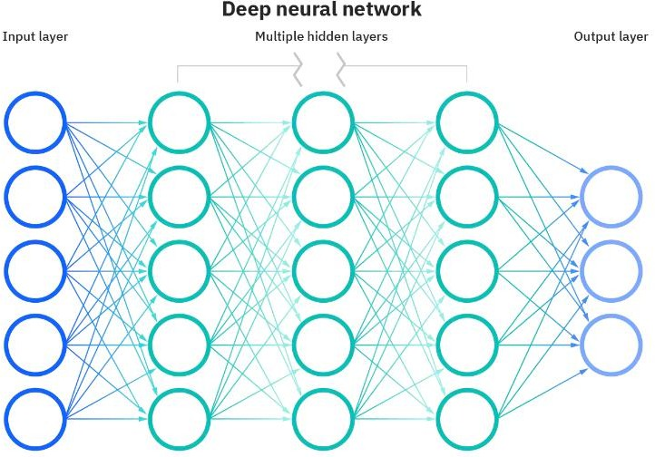

Convolutional Neural Network (CNN)
It is a feed-forward artificial neural network. It uses multilayer perceptron’s which are designed to require minimal pre-processing. When applied to NLP for text classification the sentences in the document file are represented as a square matrix, each row of which corresponds to a vector which represents a word (word embedding). Then convolution is performed on the matrix using linear filters.
A Convolutional Neural Network (CNN) provides outcomes that can be included into further training phases via matrix multiplication. This method's name is convolution Words in a sentence or a news item are represented as word vectors in the context of NLP. The training of a CNN is then done using these word vectors. By choosing a number of filters and size of the kernel, the training is done. CNN may have several dimensions.

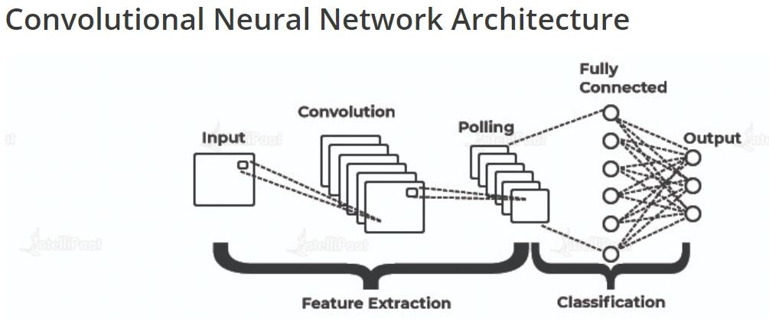
Typically, an unsupervised one-dimensional CNN (Conv1D) is used for text classification or NLP. Word vectors are represented as one-dimensional arrays called Conv_1D. In order to build an output that can be saved in an output array, training data is iterated over by a fixed-size window, which multiplies the input by the filter weights at each step. A feature map or output filter of the data is represented by this output array. The input training data is used to identify a feature in this manner. This procedure is illustrative.in Fig 3.15.
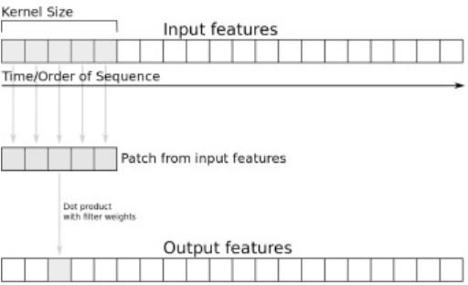

Figure 3.15: 1-D convolution operation

The number of filters and kernel size are specified, and the number of feature maps is determined by the number of filters. CNN will be able to learn local features directly from the practice set in this way.
There can be several layers in CNN. They can be of three types:
Convolutional
Max Pooling
Fully-connected

Assume that an N-N square neuron layer comes after the number of filters and kernel size are specified, and the number of feature maps is determined by the number of filters. CNN will be able to learn local features directly from the practice set in this way.

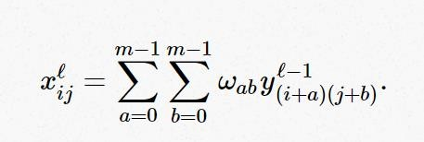
To summarize
- CNN layer accepts an input volume with the dimensions Winput x Hinput xDinput (Winput = Hinput is a common occurrence because inputs are normally squares).
- Calls for four parameters
  - The number of filters k.
  - The Kernel size used for convolution, called the receptive field size F, is always square and results in a FxF kernel.
  - The stride S
  - P (zero padding)

CHAPTER 4
RESULTS AND DISCUSSION

Algorithm‟s accuracy depends on the type and size of your dataset. More the data, more chances of getting correct accuracy.
  - Machine learning depends on the variations and relations
  - Understanding what is predictable is as important as trying to predict it.
  - While making algorithm choice , speed should be a consideration factor.

4.1 REQUIREMENT ANALYSIS

Requirement analysis, also called requirement engineering, is the process of determining user expectations for a new modified product. It encompasses the tasks that determine the need for analysing, documenting, validating and managing software or system requirements. The requirements should be documentable, actionable, measurable, testable and traceable related to identified business needs or opportunities and define to a level of detail, sufficient for system design.

4.2 FUNCTIONAL REQUIREMENTS
It is a technical specification requirement for the software products. It is the first step in the requirement analysis process which lists the requirements of particular software systems including functional, performance and security requirements. The function of the system depends mainly on the quality hardware used to run the software with given functionality.

Usability

It specifies how easy the system must be use. It is easy to ask queries in any format which is short or long, porter stemming algorithm stimulates the desired response for user.

Robustness
It refers to a program that performs well not only under ordinary conditions but also under unusual conditions. It is the ability of the user to cope with errors for irrelevant queries during execution.

Security

The state of providing protected access to resource is security. The system provides good security and unauthorized users cannot access the system there by providing high security.

Reliability

It is the probability of how often the software fails. The measurement is often expressed in MTBF (Mean Time Between Failures). The requirement is needed in order to ensure that the processes work correctly and completely without being aborted. It can handle any load and survive and survive and even capable of working around any failure.

Compatibility

It is supported by version above all web browsers. Using any web servers like localhost makes the system real-time experience.

Flexibility

The flexibility of the project is provided in such a way that is has the ability to run on different environments being executed by different users.

Safety

Safety is a measure taken to prevent trouble. Every query is processed in a secured manner without letting others to know one‟s personal information.

4.3 NON- FUNCTIONAL REQUIREMENTS

Portability
It is the usability of the same software in different environments. The project can be run in any operating system.

Performance
These requirements determine the resources required, time interval, throughput and everything that deals with the performance of the system.

Accuracy
The result of the requesting query is very accurate and high speed of retrieving information. The degree of security provided by the system is high and effective.

Maintainability
Project is simple as further updates can be easily done without affecting its stability. Maintainability basically defines that how easy it is to maintain the system. It means that how easy it is to maintain the system, analyse, change and test the application. Maintainability of this project is simple as further updates can be easily done without affecting its stability.

4.4 SYSTEM DESIGN AND TESTING PLAN

INPUT DESIGN
The input design is the link between the information system and the user. It comprises the developing specification and procedures for data preparation and those steps are necessary to put transaction data in to a usable form for processing can be achieved by inspecting the computer to read data from a written or printed document or it can occur by having people keying the data directly into the system. The design of input focuses on controlling the amount of input required, controlling the errors, avoiding delay, avoiding extra steps and keeping the process simple. The input is designed in such a way so that it provides security and ease of use with retaining the privacy. Input Design considered the following things:
- What data should be given as input?
- How the data should be arranged or coded?
- The dialog to guide the operating personnel in providing input.

4.5 OUTPUT DESIGN

A quality output is one, which meets the requirements of the end user and presents the information clearly. In any system results of processing are communicated to the users and to other system through outputs. In output design it is determined how the information is to be displaced for immediate need and also the hard copy output. It is the most important and direct source information to the user. Efficient and intelligent output design improves the system‟s relationship to help user decision-making.
The output form of an information system should accomplish one or more of the following objectives.
  - Convey information about past activities, current status or projections of the
  - Future.
  - Signal important events, opportunities, problems, or warnings.
  - Trigger an action.
  - Confirm an action.

4.6 SOCIAL FEASIBILITY

The aspect of study is to check the level of acceptance of the system by the user. This includes the process of training the user to use the system efficiently. The user must not feel threatened by the system, instead must accept it as a necessity. The level of acceptance by the users solely depends on the methods that are employed to educate the user about the system and to make him familiar with it. His level of confidence must be raised so that he is also able to make some constructive criticism, which is welcomed, as he is the final user of the system.

4.7 DATA FLOW DIAGRAM

  - The DFD is also called as bubble chart. It is a simple graphical formalism that can be used to represent a system in terms of input data to the system, various processing carried out on this data, and the output data is generated by this system.
  - The data flow diagram (DFD) is one of the most important modeling tools. It is used to model the system components. These components are the system process, the data used by the process, an external entity that interacts with the system and the information flows in the system.
  - DFD shows how the information moves through the system and how it is modified by a series of transformations. It is a graphical technique that depicts information flow and the transformations that are applied as data moves from input to output.
  - DFD is also known as bubble chart. A DFD may be used to represent a system at any level of abstraction. DFD may be partitioned into levels that represent increasing information flow and functional detail.
  - It is the testing of individual software units of the application .it is done after the completion of an individual unit before integration.

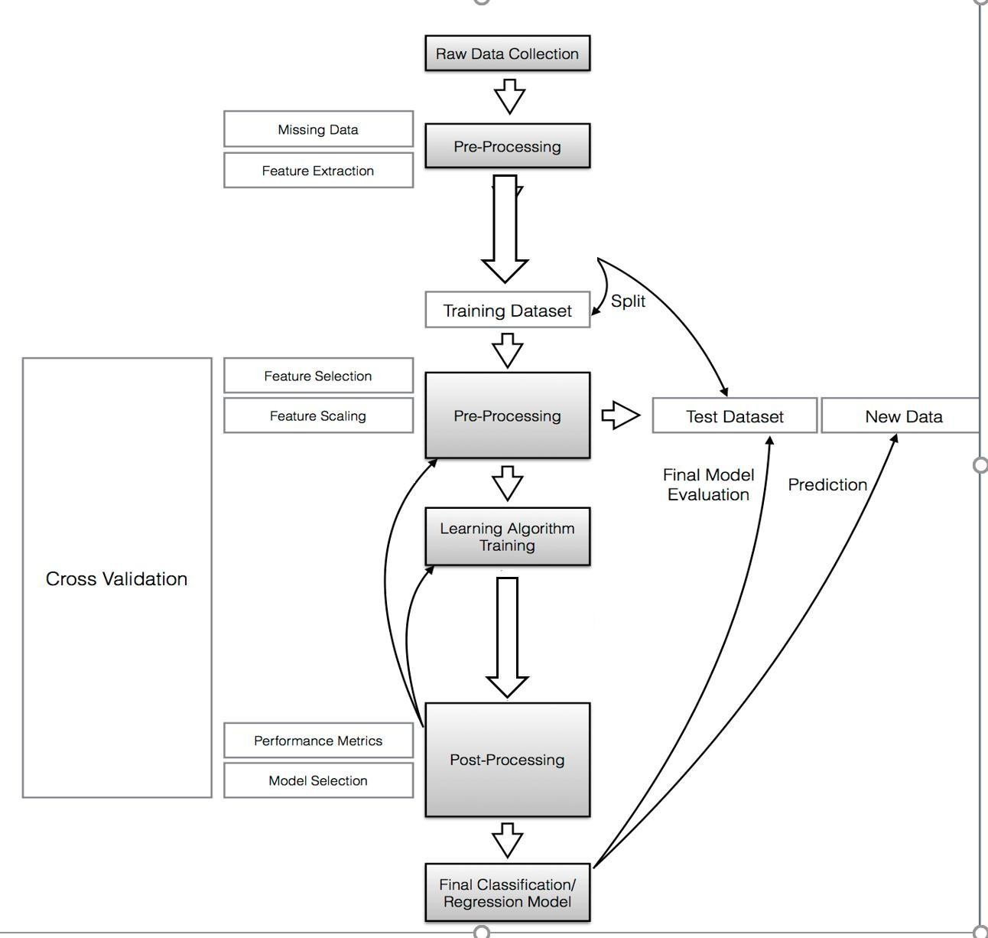

Fig:4.1 Data Flow Diagram

4.8 TEST PROCEDURE

TEST PROCEDURE
The purpose of testing is to discover errors. Testing is the process of trying to discover every conceivable fault or weakness in a work product. It provides a way to check the functionality of components, sub assemblies, assemblies and/or a finished product It is the process of exercising software with the intent of ensuring that the Software system meets its requirements and user expectations and does not fail in an unacceptable manner. There are various types of test. Each test type addresses a specific testing requirement.

4.9 UNIT TESTING
Unit testing involves the design of test cases that validate that the internal program logic is functioning properly, and that program inputs produce valid outputs. All decision branches and internal code flow should be validated. It is the testing of individual software units of the application .it is done after the completion of an individual unit before integration. This is a structural testing, that relies on knowledge of its construction and is invasive. Unit tests perform basic tests at component level and test a specific business process, application, and/or system configuration. Unit tests ensure that each unique path of a business process performs accurately to the documented specifications and contains clearly defined inputs and expected results.
4.10 INTEGRATION TESTING
Integration tests are designed to test integrated software components to determine if they actually run as one program. Testing is event driven and is more concerned with the basic outcome of screens or fields. Integration tests demonstrate that although the components were individually satisfaction, as shown by successfully unit testing, the combination of components is correct and consistent. Integration testing is specifically aimed at exposing the problems that arise from the combination of components.

4.11 FUNCTIONAL TESTING
Functional tests provide systematic demonstrations that functions tested are available as specified by the business and technical requirements, system documentation, and user manuals.
Functional testing is centered on the following items:

Valid Input: identified classes of valid input must be accepted. Invalid Input: identified classes of invalid input must be rejected. Function: identified functions must be exercised.
Output: identified classes of application outputs must be exercised. Organization and preparation of functional tests is focused on requirements, key functions, or special test cases. In addition, systematic coverage pertaining to identify Business process flows; data fields, predefined processes, and successive processes must be considered for testing. Before functional testing is complete, additional tests are identified and the effective value of current tests is determined.
4.12 WHITE BOX TESTING
White Box Testing is a testing in which in which the software tester has knowledge of the inner workings, structure and language of the software, or at least its purpose. It is purpose. It is used to test areas that cannot be reached from a black box level.Black Box Testing is testing the software without any knowledge of the inner workings, structure or language of the module being tested. Black box tests, as most other kinds of tests, must be written from a definitive source document, such as specification or requirements document, such as specification or requirements document. It is a testing in which the software under test is treated, as a black box .you cannot “see” into it. The test provides inputs and responds to outputs without considering how the software works
4.13 ACCEPTANCE TESTING
User Acceptance Testing is a critical phase of any project and requires significant participation by the end user. It also ensures that the system meets the functional requirements.

CHAPTER 5
Advantages of the Proposed Deep Learning-Based LSTM System

Captures Long-Term Dependencies
The LSTM model can remember information for long periods, allowing it to learn complex patterns from sequential or time-series data more effectively than traditional machine learning models.
High Prediction Accuracy
Deep learning models automatically learn important features from the data, which improves the accuracy and reliability of the prediction results.
Effective for Sequential Data
LSTM networks are specifically designed to process sequential data such as audio signals, behavioral activity logs, or time-series datasets.
Automatic Feature Learning
Unlike traditional methods that require manual feature engineering, the LSTM model can automatically learn meaningful features during training.
Handles Large Datasets Efficiently
The proposed system can process and analyze large volumes of data efficiently, making it suitable for real-time or large-scale applications.

5.1 DISADVANTAGE OF THE EXISTING SYSTEM
Low Prediction Accuracy
Traditional systems often rely on basic machine learning or manual analysis, which may not capture complex patterns effectively, leading to lower accuracy.
Inability to Handle Sequential Data
Existing systems are not designed to process time-dependent or sequential data efficiently, which reduces their effectiveness in analyzing patterns over time.
Manual Feature Extraction
Many traditional systems require manual feature engineering, which is time-consuming and may miss important hidden patterns in the data.
Poor Performance with Large Datasets
Conventional methods may struggle when handling large volumes of data, leading to slower processing and reduced efficiency.
Limited Learning Capability
Existing systems often cannot learn long-term dependencies or complex relationships within the dataset.

5.2 CONCLUSION
In conclusion, the proposed system based on a Deep Learning LSTM model provides an effective solution for analyzing sequential data and making accurate predictions. By applying proper data preprocessing, feature extraction, and model training techniques, the system is able to learn complex patterns and long-term dependencies present in the dataset. Compared to traditional methods, the LSTM-based approach offers improved accuracy, better handling of time-dependent data, and reduced manual intervention. The system can efficiently process large datasets and provide reliable prediction results, making it suitable for various real-world applications such as audio analysis, behavioral monitoring, and time-series prediction. Therefore, the implementation of the deep learning-based LSTM model enhances the overall performance and reliability of the system.

5.3 FUTURE ENHANCEMENTS
- Integration with Larger Datasets
In the future, the system can be trained with larger and more diverse datasets to improve the accuracy and robustness of the prediction model.
- Real-Time Data Processing
The system can be enhanced to support real-time data analysis and prediction, allowing faster and more dynamic decision-making.
- Improved Model Architecture
Advanced deep learning architectures such as Bidirectional LSTM or hybrid models combining CNN and LSTM can be implemented to further improve performance.
- Cloud-Based Deployment
The system can be deployed on cloud platforms to enable scalable processing, remote access, and better resource management.
- User-Friendly Interface
A more interactive and user-friendly web or mobile application interface can be developed to make the system easier to use.
- Integration with IoT or Sensor Devices
The system can be integrated with IoT devices or sensors to automatically collect data and perform continuous monitoring.

5.4 REFERENCES
- Sepp Hochreiter and Jürgen Schmidhuber, “Long Short-Term Memory,” Neural Computation, vol. 9, no. 8, pp. 1735–1780, 1997.
- Ian Goodfellow, Yoshua Bengio, and Aaron Courville, Deep Learning, MIT Press, 2016.
- Francois Chollet, Deep Learning with Python, Manning Publications, 2017.
- TensorFlow Documentation. Available: https://www.tensorflow.org
- Keras Documentation. Available: https://keras.io
- IEEE Xplore Digital Library. Available: https://ieeexplore.ieee.org
- ScienceDirect Research Articles Database. Available: https://www.sciencedirect.com
- Google Scholar Academic Research Search Engine. Available: https://scholar.google.com

5.5 BIBLIOGRAPHY
https://docs.python.org/3/tutorial/
https://www.freecodecamp.org
https://www.codecademy.com/learn/learn-python-3
https://www.coursera.org
https://www.geeksforgeeks.org/python-programming-language/
https://www.w3schools.com/python/
https://realpython.com
https://www.kaggle.com/learn/python

Table Design
Table Name: User Table

Field Name | Data Type | Description
user_id | Integer (Primary Key) | Unique ID for each user
username | Varchar | Name of the user
email | Varchar | User email address
password | Varchar | Encrypted password
phone_number | Varchar | Contact number
registration_date | DateTime | Date when the user registered

5.6 PREDICTION TABLE
Field Name | Data Type | Description
prediction_id | Integer (Primary Key) | Unique ID for each prediction
user_id | Integer (Foreign Key) | Reference to user table
input_data | Text | Input data given by the user
prediction_result | Varchar | Model prediction result
confidence_score | Float | Accuracy or probability score
created_at | DateTime | Time when prediction was made

5.7 DFD

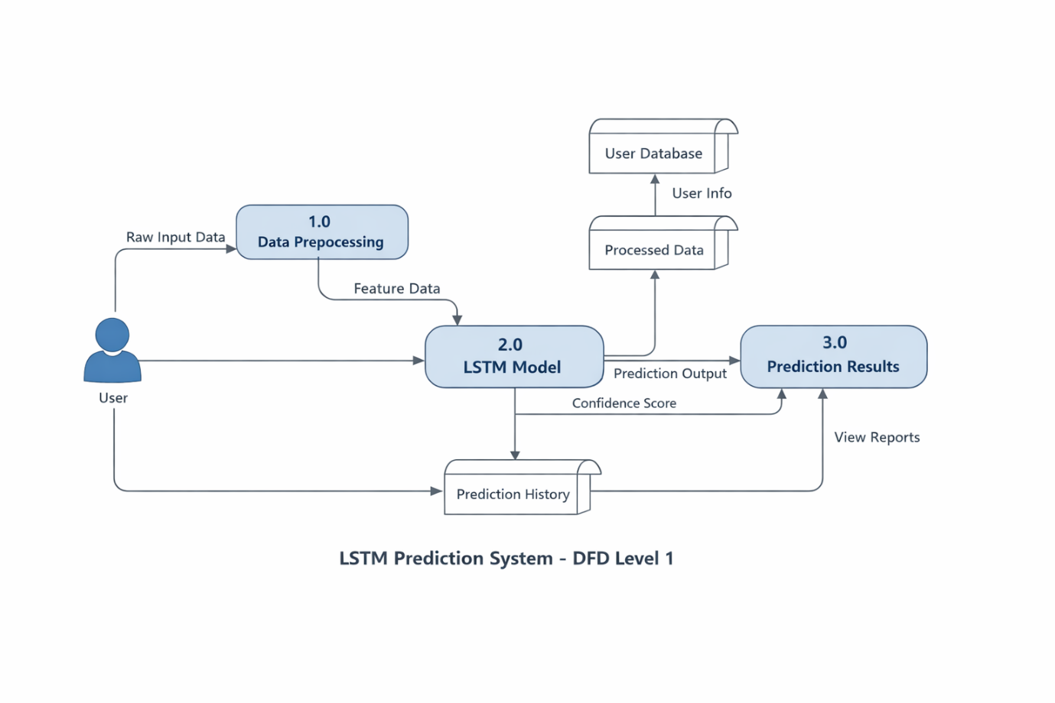

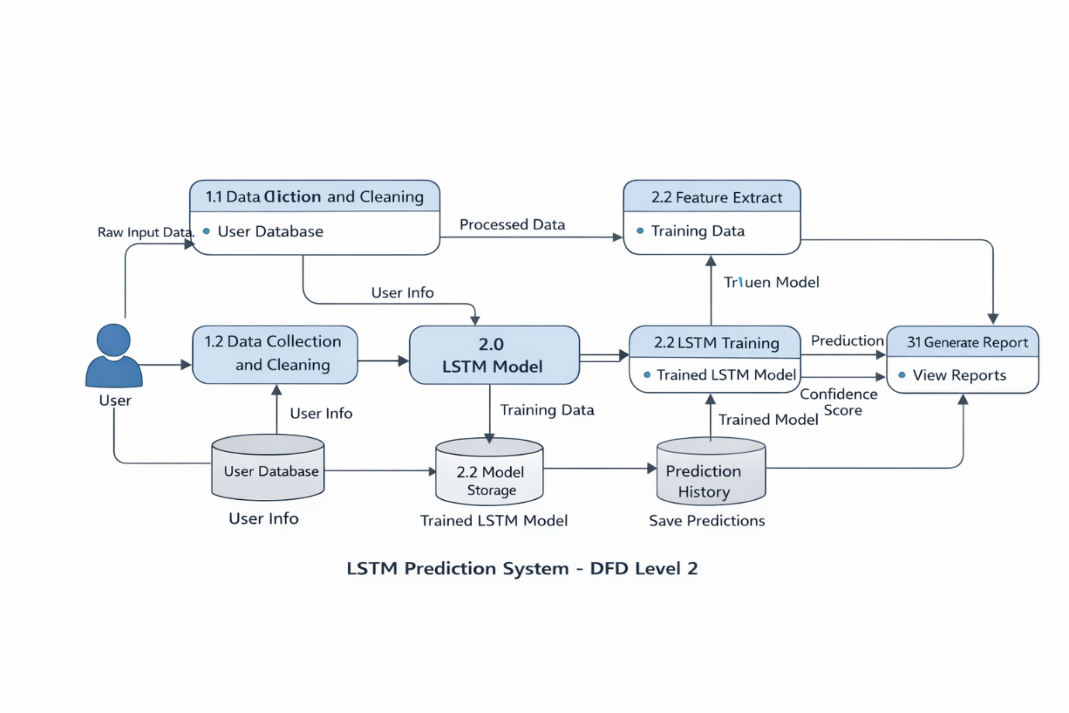

5.8 ER DIAGRAM

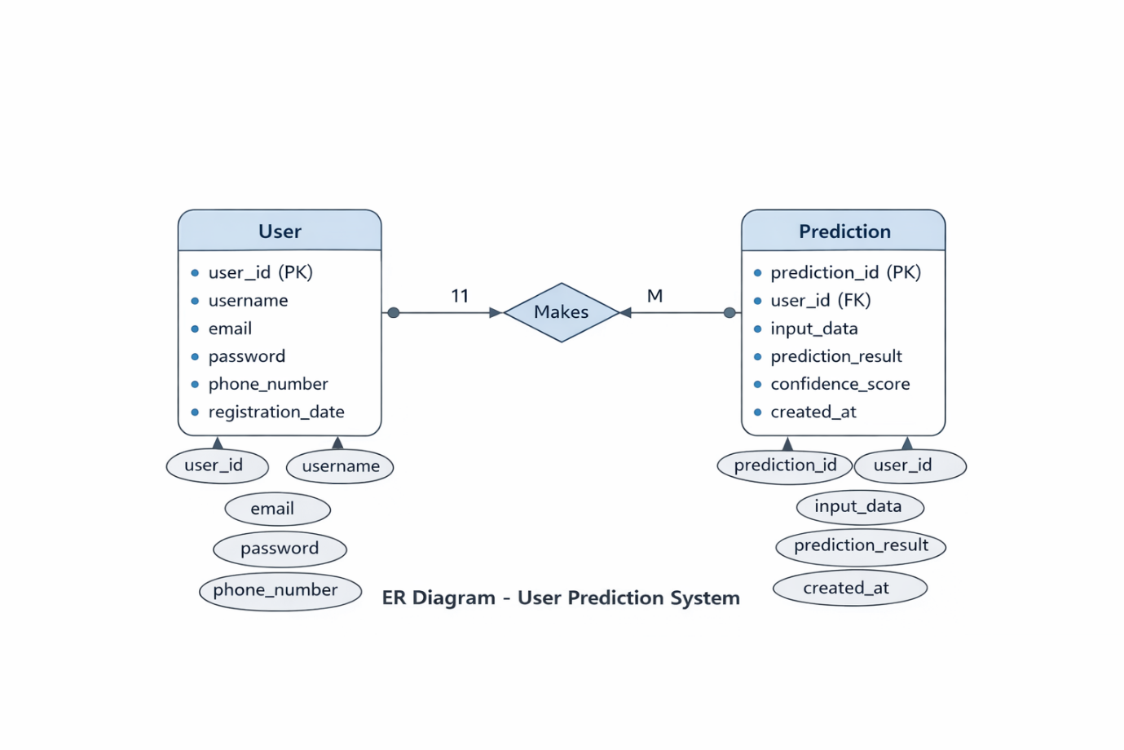

CHAPTER 6

6.1 CONCLUSION AND FUTURE WORK

Many people consume news from social media instead of traditional news media. However, social media has also been used to spread fake news, which has negative impacts on individual people and society. In this paper, an innovative model for fake news detection using machine learning algorithms has been presented. This model takes news events as an input and based on twitter reviews and classification algorithms it predicts the percentage of news being fake or real.

The feasibility of the project is analyzed in this phase and business proposal is put forth with a very general plan for the project and some cost estimates. During system analysis the feasibility study of the proposed system is to be carried out. This is to ensure that the proposed system is not a burden to the company. For feasibility analysis, some understanding of the major requirements for the system is essential.This study is carried out to check the economic impact that the system will have on the organization. The amount of fund that the company can pour into the research and development of the system is limited. The expenditures must be justified. Thus the developed system as well within the budget and this was achieved because most of the technologies used are freely available. Only the customized products had to be purchased.

6.2 REFERENCES

[1]. Parikh, S. B., & Atrey, P. K. (2018, April). Media-Rich Fake News Detection: A Survey. In 2018 IEEE Conference on Multimedia Information Processing and Retrieval (MIPR) (pp. 436-441). IEEE.

[2]. Conroy, N. J., Rubin, V. L., & Chen, Y. (2015, November). Automatic deception detection: Methods for finding fake news. In Proceedings of the 78th ASIS&T Annual Meeting: Information Science with Impact: Research in and for the Community (p. 82). American Society for Information Science.

[3]. Helmstetter, S., & Paulheim, H. (2018, August). Weakly supervised learning for fake news detection on Twitter. In 2018 IEEE/ACM International Conference on Advances in Social Networks Analysis and Mining (ASONAM) (pp. 274-277). IEEE. [4]. Stahl, K. (2018). Fake News Detection in Social Media.

[5]. Della Vedova, M. L., Tacchini, E., Moret, S., Ballarin, G., DiPierro, M., & de Alfaro, L. (2018, May). Automatic Online Fake News Detection Combining Content and Social Signals. In 2018 22nd Conference of Open Innovations Association (FRUCT) (pp. 272-279). IEEE.

[6] Tacchini, E., Ballarin, G., Della Vedova, M. L., Moret, S., & de Alfaro, L. (2017). Some like it hoax: Automated fake news detection in social networks. arXiv preprint arXiv:1704.07506.
[7]. Shao, C., Ciampaglia, G. L., Varol, O., Flammini, A., & Menczer, F. (2017). The spread of fake news by social bots. arXiv preprint arXiv:1707.07592, 96-104.
[8]. Chen, Y., Conroy, N. J., & Rubin, V. L. (2015, November). Misleading online content: Recognizing clickbait as false news. In Proceedings of the 2015 ACM on Workshop on Multimodal Deception Detection (pp. 15-19). ACM.
[9]. Najafabadi, M. M., Villanustre, F., Khoshgoftaar, T. M., Seliya, N., Wald, R., & Muharemagic, E. (2015). Deep learning applications and challenges in big data analytics. Journal of Big Data, 2(1), 1.

[10]. Haiden, L., & Althuis, J. (2018). The Definitional Challenges of Fake News.

6.3 APPENDIX

- A) App.py

from flask import Flask, render_template, request, redirect, url_for, session, flash
import pickle
import os
from datetime import datetime
import json
import tensorflow as tf
from tensorflow.keras.preprocessing.sequence import pad_sequences

model_LSTM = tf.keras.models.load_model("final_model.h5")

app = Flask(__name__)
app.secret_key = 'your-secret-key-here' # Change in production

# ======================
# Paths
# ======================
BASE_DIR = os.path.dirname(os.path.abspath(__file__))
HISTORY_FILE = os.path.join(BASE_DIR, 'prediction_history.json')

# ======================
# Load trained model & vectorizer
# ======================
loaded_model = pickle.load(open(os.path.join(BASE_DIR, 'model.pkl'), 'rb'))
tfvect = pickle.load(open(os.path.join(BASE_DIR, 'vectorizer.pkl'), 'rb'))

# ======================
# Helper Functions
# ======================
def load_history():
if os.path.exists(HISTORY_FILE):
with open(HISTORY_FILE, 'r') as f:
try:
data = json.load(f)
return data if isinstance(data, list) else []
except:
return []
return []

def save_history(history):
with open(HISTORY_FILE, 'w') as f:
json.dump(history[-100:], f, indent=4) # keep last 100 only

def fake_news_det(news):
input_data = [news]
vectorized_input_data = tfvect.transform(input_data)

prediction = loaded_model.predict(vectorized_input_data)[0]

# Get confidence score
if hasattr(loaded_model, "decision_function"):
confidence_score = loaded_model.decision_function(vectorized_input_data)[0]
confidence = round(abs(confidence_score) * 10, 2)
confidence = min(confidence, 99) # cap at 99%
else:
confidence = 85 # fallback

label = "REAL" if prediction == 1 else "FAKE"

return label, confidence

# ======================
# Routes
# ======================
@app.route("/")
def home():
return render_template("home.html")

@app.route("/register", methods=["GET", "POST"])
def register():
if request.method == "POST":
flash('Registration successful! Please login.', 'success')
return redirect(url_for('login'))
return render_template("register.html")

@app.route("/login", methods=["GET", "POST"])
def login():
if request.method == "POST":
session['logged_in'] = True
session['username'] = request.form.get('username')
flash('Login successful!', 'success')
return redirect(url_for('dashboard'))
return render_template("login.html")

@app.route("/logout")
def logout():
session.clear()
flash('You have been logged out.', 'info')
return redirect(url_for('home'))

@app.route("/dashboard")
def dashboard():
if not session.get('logged_in'):
return redirect(url_for('login'))

history = load_history()
total_predictions = len(history)
fake_count = len([h for h in history if h['prediction'] == 'FAKE'])
real_count = total_predictions - fake_count

return render_template("dashboard.html",
total_predictions=total_predictions,
fake_count=fake_count,
real_count=real_count,
username=session.get('username'))

@app.route("/predict", methods=["GET", "POST"])
def predict():
if not session.get('logged_in'):
return redirect(url_for('login'))

if request.method == "POST":
message = request.form.get("message")

if message:
pred, confidence = fake_news_det(message)

history = load_history()
history.append({
'id': len(history) + 1,
'text': message[:100] + '...' if len(message) > 100 else message,
'prediction': pred,
'confidence': confidence,
'timestamp': datetime.now().strftime("%Y-%m-%d %H:%M:%S"),
})
save_history(history)

return redirect(url_for('result',
prediction=pred,
text=message,
confidence=confidence))

return render_template("predict.html")

@app.route("/result")
def result():
if not session.get('logged_in'):
return redirect(url_for('login'))

prediction = request.args.get('prediction', 'UNKNOWN')
text = request.args.get('text', '')
confidence = float(request.args.get('confidence', 0))

return render_template("result.html",
prediction=prediction,
text=text,
confidence=confidence)

@app.route("/history")
def history():
if not session.get('logged_in'):
return redirect(url_for('login'))

history = load_history()
reversed_history = list(reversed(history))

return render_template("history.html", history=reversed_history)

@app.route("/analysis")
def analysis():
if not session.get('logged_in'):
return redirect(url_for('login'))

history = load_history()

total = len(history)
fake_count = len([h for h in history if h['prediction'] == 'FAKE'])
real_count = total - fake_count

recent = history[-10:] if len(history) >= 10 else history

monthly_data = {}
for entry in history[-30:]:
month = entry['timestamp'][:7]
monthly_data[month] = monthly_data.get(month, 0) + 1

return render_template("analysis.html",
total=total,
fake_count=fake_count,
real_count=real_count,
recent=recent,
monthly_data=monthly_data)

# ======================
# Run App
# ======================
if __name__ == "__main__":
app.run(debug=True)
6.4 OUTPUT

Main Page

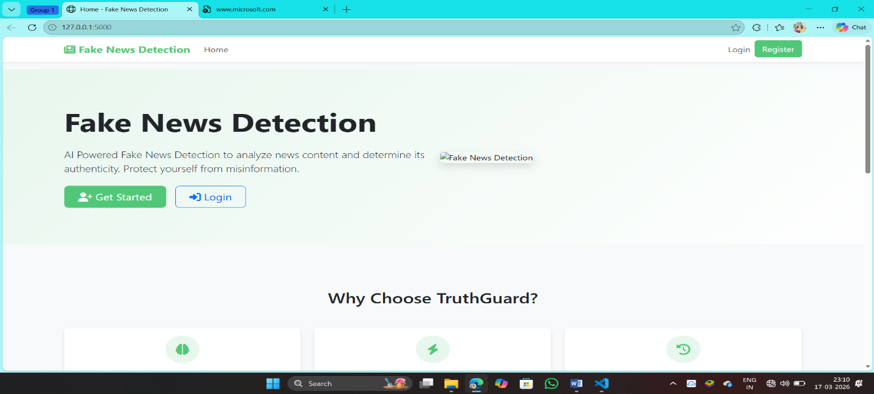

Register Page
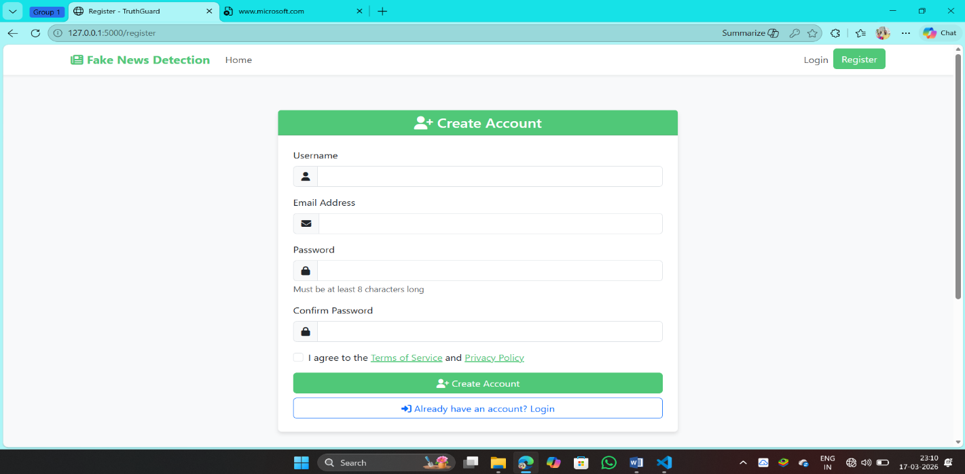

Login Page

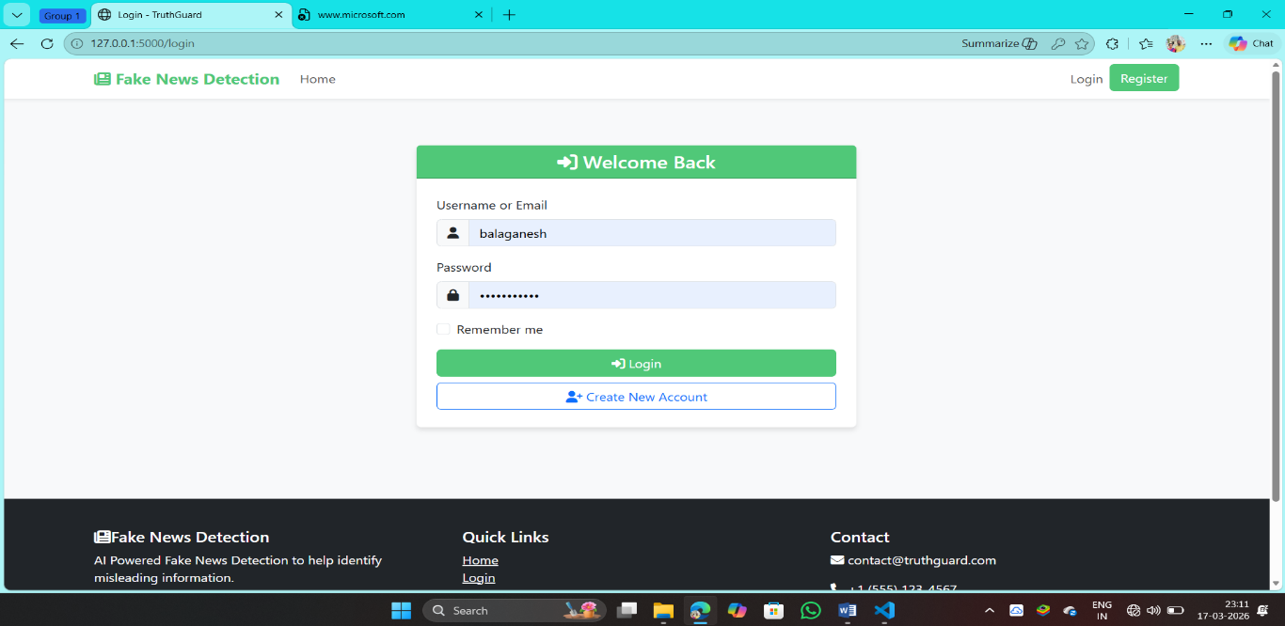

Home Page



Analysis History Page



Prediction Page


Analysis Dashboard

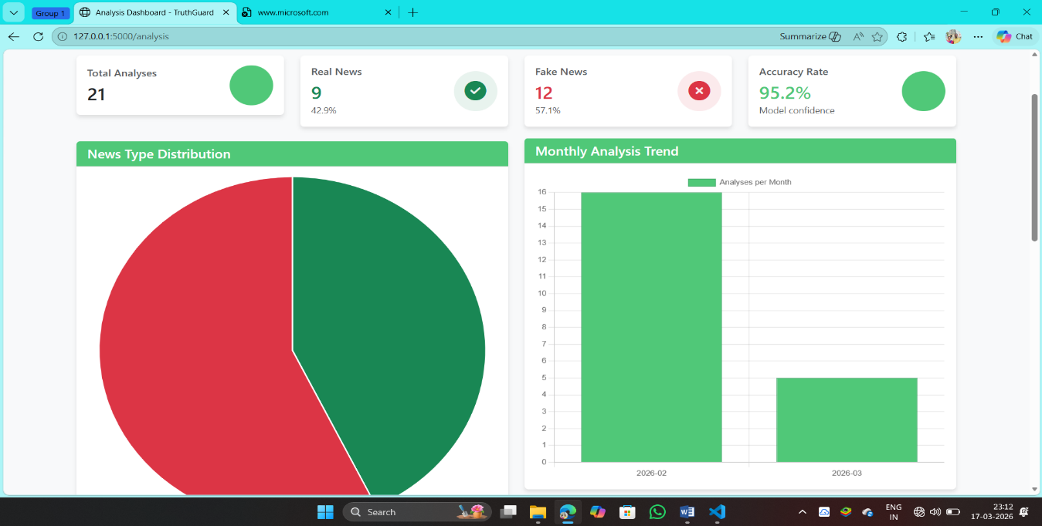

Dataset



